Skill program
Skill program 2: To Create Main Loop, Display Prompt, Read User Input, Handle Exit Conditions, Design Control Flow Diagram, Test Interactive Loop
To Capture Keyboard Input, Handle Backspace, Process Enter Key, Manage Input Buffer, Support Multi-Character Commands, Test User Interaction

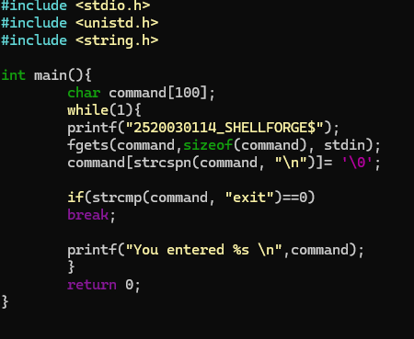
Output
